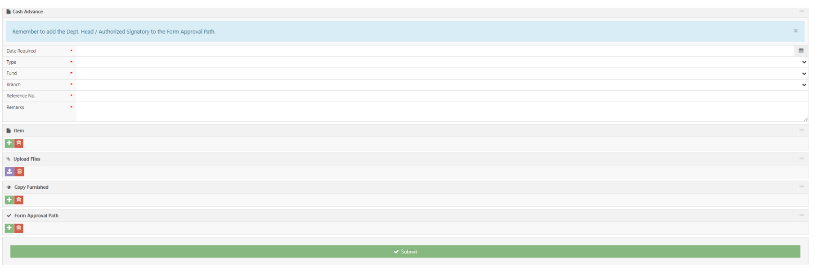
Bank Name:
Account Name:
Account Number:
If they choose FOR DEPOSIT, please add space for the following:

FOR PICK UP
FOR DEPOSIT
Mode of Payment*:
This should be – checkbox
Due Date*:

NOTE: THIS ADDITIONS SHOUL=D BE REFLECTED UPON PRINTING OF THE APV FORM

